

|  |  |  |
| --- | --- | --- |
|  | [Journal of the European Ceram ic Society 39 (2019) 4038–4045](https://doi.org/10.1016/j.jeurceramsoc.2019.05.065) |  |
|  | Contents lists available at [ScienceDirect](http://www.sciencedirect.com/science/journal/09552219) |  |
| Journal of the European Ceramic Society |
| journal homepage: [www.elsevier.com/locate/jeurceramsoc](https://www.elsevier.com/locate/jeurceramsoc) |

Original Article

Modulation of ferroelectricity and antiferroelectricity of nanoscale ZrO2 thin films using ultrathin interfacial layers [T](http://crossmark.crossref.org/dialog/?doi=10.1016/j.jeurceramsoc.2019.05.065&domain=pdf)

Sheng-Han Yi, Bo-Ting Lin, Tzu-Yao Hsu, Jay Shieh⁎, Miin-Jang Chen⁎

Department of Materials Science and Engineering, National Taiwan University, 1 Roosevelt Road, Sec. 4, Taipei 106, Taiwan

|  |  |
| --- | --- |
| A R T I C L E I N F O | A B S T R A C T |
| Keywords:  ZrO2  Ferroelectricity  Antiferroelectricity  Interfacial layers | In this study, tailoring the microstructures and ferroelectric(FE)/antiferroelectric(AFE) properties of nanoscale  ZrO2 thin films is demonstrated with an intentional introduction of sub-nanometre interfacial layers. The fer-roelectricity of ZrO2 thin films is significantly enhanced by the HfO2 interfacial layers, while the TiO2 interfacial layers lead to a dramatic transformation of ZrO2 from ferroelectricity into antiferroelectricity. The HfO2 and TiO2 interfacial layers boost the formation of the polar orthorhombic phase with (111)-texture and the non-polar tetragonal phase with (110)-texture in the FE/AFE ZrO2 thin films, respectively, as evidenced by grazing in-cidence, out-of-plane, and in-plane X-ray diffraction measurements. Furthermore, the modulation of ferroelec- |

tricity and antiferroelectricity of nanoscale ZrO2 thin films by the HfO2/TiO2 interfacial layers can be achieved without high-temperature annealing, which is highly advantageous to process integration. The findings de-monstrate the important role of the interfaces in the effective tuning of FE/AFE properties of nanoscale thin films.

|  |  |
| --- | --- |
| 1. Introduction | ultralow-power nanoelectronics. |

Conventional FE/AFE materials are perovskite oxides, such as lead

Ferroelectric (FE) materials have spontaneous polarization and can undergo polarization switching by application of an external electric field. Through reading their polarization states, FEs can be utilized in memory applications, including ferroelectric random access memory, ferroelectric field-effect transistors, and ferroelectric tunnel junction [1–3]. On the other hand, antiferroelectric (AFE) materials have no macroscopic polarization and can experience reversible field-induced phase transition from either an anti-polar or non-polar phase to a FE phase under an applied electric field [4,5]. Because of the considerable variation of polarization and volume during the phase transition, AFEs have great potential in energy storage and conversion, pyroelectric energy harvesting, electrocaloric cooling, and infrared sensing for thermal imaging [6–10]. Although AFEs are generally considered un-suitable for memory applications due to the lack of remanent polar-ization (Pr), nonvolatile memory devices based on AFEs have been demonstrated based on a built-in field created by asymmetric electrodes with different workfunctions or stabilization of the FE phase by stacking layers [11,12]. In addition, FE and AFE materials could provide nega-tive capacitance during polarization switching [13,14]. With the in-tegration of FEs/AFEs into the gate-stack of nanoscale transistors, the subthreshold swing can be reduced to below 60 mV per decade [15,16]. Hence, FE and AFE dielectrics show promising applications in future

⁎ Corresponding authors.

zirconate titanate (PZT) and lead zirconate (PZ) systems [2,17]. They are, however, not environment-friendly due to the presence of lead. In recent years, HfO2- and ZrO2-based thin films have been discovered to possess (anti)ferroelectricity [18–20]. Owing to the compatibility with complementary metal-oxide-semiconductor (CMOS) processing, HfO2 and ZrO2 have become prospective candidates for novel device appli-cations.

The ferroelectricity in HfO2- and ZrO2-based materials has been attributed to the polar non-centrosymmetric orthorhombic crystalline structure (space group: Pca21, o-phase) [18,19,21], which was first discovered in Mg-doped ZrO2 [22]. On the other hand, the origin of the antiferroelectricity in HfO2- and ZrO2-based materials has been re-cognized as the phase transformation between the nonpolar tetragonal crystalline structure (space group: P42/nmc, t-phase) and the o-phase when an electric field is applied [18,19,23]. The most stable crystalline structure in HfO2 and ZrO2, however, is the monoclinic phase (space group: P21/c, m-phase) under room temperature and atmospheric pressure [24,25]. To stabilize the o-phase or t-phase in HfO2 or ZrO2 thin films, impurity doping or alloying has often been adopted [18,26–28]. Nevertheless, doping or alloying engineering usually re-quires high-temperature annealing to achieve the (anti)ferroelectricity, which is unfavorable to process integration and device scaling

E-mail addresses: [jayshieh@ntu.edu.tw](mailto:jayshieh@ntu.edu.tw) (J. Shieh), [mjchen@ntu.edu.tw](mailto:mjchen@ntu.edu.tw) (M.-J. Chen).

<https://doi.org/10.1016/j.jeurceramsoc.2019.05.065>  
[Available online 31 M](https://doi.org/10.1016/j.jeurceramsoc.2019.05.065) 0955-2219/ © 2019 Elsevier Ltd. All rights reserved. ay 2019   
Received 13 February 2019; Received in revised form 27 May 2019; Accepted 30 May 2019

S.-H. Yi, et al. *Journal of the European Ceram ic Society 39 (2019) 4038–4045*

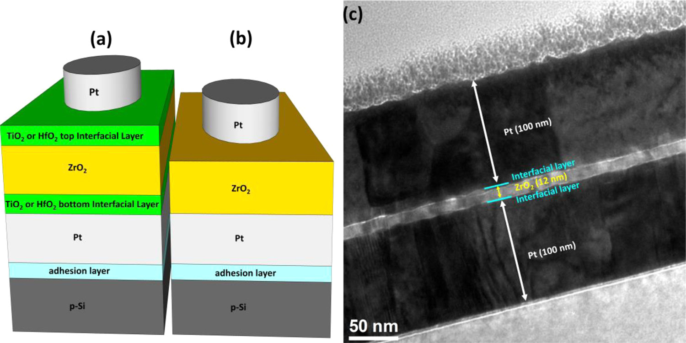

Fig. 1. Schematic illustration of the ZrO2 MIM structure a) with HfO2 or TiO2 interfacial layers and b) without the interfacial layers. The interfacial layers are inserted

between the ZrO2 thin film and the Pt top/bottom electrodes. c) Cross-sectional TEM micrograph of the TZT sample.

[18,26–28]. Besides, non-uniform distribution of dopants in FE/AFE thin films may be a concern.

It has also been reported that electrode materials used in metal-insulator-metal (MIM) structures have a great impact on the FE/AFE characteristics of HfO2- or ZrO2- based thin films. For instance, the solid solution of 50% HfO2 and 50% ZrO2 (Hf0.5Zr0.5O2, abbreviated HZO) exhibits ferroelectricity on TiN electrode but paraelectric on Pt elec-trode [29]. One the other hand, for pure ZrO2 thin films, anti-ferroelectricity has been observed in the TiN/ZrO2/TiN structure [12,19,30] while ferroelectricity has been measured in the Pt/ZrO2/Pt structure, respectively [31,32]. The results suggest that the interface between the electrodes and the oxide layer plays an important role in tailoring the FE/AFE properties.

In this paper, we report on the discovery of a novel way to modulate the FE/AFE characteristics of ZrO2 thin films through sub-nanometer interfacial layers. The HfO2 interfacial layers enhance the FE properties, while the TiO2 interfacial layers convert the original FE ZrO2 into AFE. The remanent polarization of the FE ZrO2 is enhanced by the in-troduction of the HfO2 interfacial layers, which is attributed to the formation of the o-phase with (111) preferred orientation. The anti-ferroelectricity of the ZrO2 with the TiO2 interfacial layers is confirmed to originate from the presence of the t-phase. Utilizing the HfO2/TiO2 interface engineering to modulate the FE/AFE properties of ZrO2 thin films is a feasible and practical method for precise control and fabri-cation. In addition, the HfO2/TiO2 interface engineering does not re-quire high-temperature annealing compared to the doping engineering, which is highly beneficial for CMOS process integration. The results demonstrate the significant impact of interfacial materials on the for-mation of FE/AFE crystalline phases in ZrO2 thin films.

2. Experimental section

The fabrication of the metal-insulator-metal (MIM) structures is described as follows. First, a Pt bottom electrode (∼100 nm thick) was deposited on a TiO2/Si substrate structure by magnetron sputtering, where the TiO2 layer serves as an adhesion layer. Next, a HfO2 or TiO2 bottom interfacial layer was deposited on the Pt bottom electrode. Then a ∼12-nm ZrO2 thin film was deposited on the bottom interfacial layer. Subsequently, a top HfO2 or TiO2 interfacial layer was deposited on the ZrO2 thin film. All the HfO2, TiO2, and ZrO2 layers were prepared by remote plasma atomic layer deposition (ALD) (Fiji, Cambridge Nanotech) at 300 °C. Tetrakis(dimethylamino)hafnium (Hf[N(CH3)2]4), Tetrakis(dimethylamino)titanium (Ti[N(CH3)2]4), Tetrakis(dimethyla-mino)zirconium (Zr[N(CH3)2]4, TDMAZ), and oxygen plasma were the sources for Hf, Ti, Zr, and O, respectively. The HfO2 and TiO2 interfacial

layers were deposited with 6 and 10 ALD cycles, and the growth per cycle (GPC) of the HfO2 and TiO2 was ∼1.6 and ∼0.8 Å/cycle, re-spectively. Afterwards, a Pt top electrode is deposited by magnetron sputtering. The electrode of a diameter of 200 μm was defined using optical lithography and lift-off process. Finally, the MIM structures were treated with a post-metallization annealing (PMA) process at 600 °C in N2 atmosphere for 30 s using rapid thermal annealing. Because platinum has low reactivity with oxide thin films, it was chosen as the electrode material to prevent the formation of any undesired interfacial layer.

Transmission electron microscopy (TEM) and energy-dispersive X-ray spectroscopy (EDS) analyses of the thin films were carried out by a high-resolution transmission microscope (2010 F, JEOL) operating at

|  |  |  |  |  |  |  |
| --- | --- | --- | --- | --- | --- | --- |
| 200 kV | equipped | with | an | energy-dispersive | X-ray | spectrometer. |

Dynamic hysteresis measurements were performed with a bipolar tri-angular voltage excitation at 2 kHz using a ferroelectric analyser (TF2000, aixACCT). The capacitance-voltage (C–V) characteristics of the samples were measured by a Keithley 4200-SCS semiconductor characterization system. The grazing incidence (2θ), out-of-plane (2θ/ ω), and in-plane (2θχ/φ) X-ray diffraction (XRD) measurements were performed using an X-ray diffractometer (TTRAX III, Rigaku) with Cu-Kα radiation (λ = 0.154 nm). The grazing incidence X-ray diffraction (GIXRD) was measured at an incident angle of 0.5°.

3. Results and discussion

MIM structures, as illustrated schematically in Fig. 1a, were fabri-cated to characterize the FE/AFE properties of ZrO2 thin films with the HfO2/TiO2 interfacial layers. Another ZrO2 MIM structure prepared with the same processing condition but without the interfacial layers, as shown in Fig. 1b, was also fabricated to serve as a reference sample (denoted as the ZO sample). For convenience in the following discus-sion, the MIM structures with the HfO2 and TiO2 interfacial layers are abbreviated as the HZH and TZT samples, where the symbol Z, H and T represent ZrO2, HfO2, and TiO2, respectively. Fig. 1c shows the cross-sectional TEM image of the TZT sample, revealing that the ZrO2 thickness is around 12 nm.

Fig. 2 displays the cross-sectional high-resolution TEM (HRTEM) micrograph of the ZO, HZH, and TZT samples. The thicknesses of the ZO, HZH, and TZT thin films are approximately 12 nm, 13 nm, and 14 nm thick, respectively. Although the thicknesses of the HfO2 and TiO2 interfacial layers cannot be clearly distinguished in the images, they could be estimated to be less than 1 nm according to the difference in the thickness between the ZO and HZH/TZT thin films, as well as the number of the applied ALD cycles and the GPC of the respective films.

4039

S.-H. Yi, et al. *Journal of the European Ceram ic Society 39 (2019) 4038–4045*

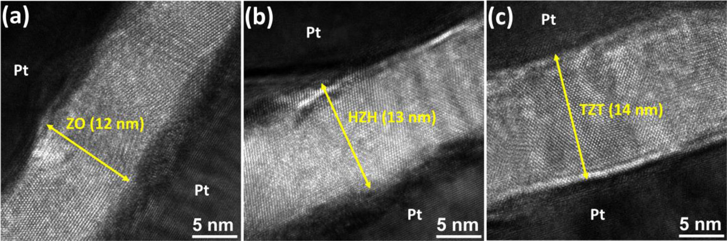

Fig. 2. Cross-sectional HRTEM images of the a) ZO, b) HZH, and c) TZT samples after 600 °C N2 annealing for 30 s, in which the oxide thickness is ∼12, 13, and

14 nm, respectively.

Fig. 3 shows the EDS line profile across the cross-section of the HZH and TZT structures. The profiles reveal the presence of Hf and Ti element at the interfaces between Pt electrodes and ZrO2 thin films, verifying the presence of the HfO2 and TiO2 bottom/top interfacial layers in the HZH and TZT samples, respectively.

Fig. 4 shows the polarization-electric field (P-E) and current density-electric field (J-E) curves of the ZO, HZH, and TZT samples. As shown in Fig. 4a, the ZO thin film exhibits FE behaviours with a Pr of 12.6 μC cm−2. As compared with the ZO sample, the introduction of the HfO2 interfacial layers results in significant enhancement of the ferroelec-tricity of the HZH sample, as manifested by the significant switching current in the J-E curves and the enhanced Pr of 17.6 μC cm−2as shown in Fig. 4b. On the other hand, the TZT thin film shows double hysteresis loops in the P-E curve and quadruple peaks of switching currents in the J-E curve, which are typical characteristics of AFE materials, as de-monstrated in Fig. 4c. Each of the switching currents is associated with the phase transition between the non-polar and the polar phase, leading to a sudden change in the displacement current [19,23,33]. The result indicates that the dielectric properties of the ZrO2 thin film can be converted from ferroelectricity to antiferroelectricity by sub-nanometre TiO2 interfacial layers.

The dramatic transformation of the dielectric properties of the ZrO2 may be attributed to the tailoring of the crystalline phases in the ZrO2 layer by the HfO2 and TiO2 interfacial layers. Hence grazing incidence, out-of-plane, and in-plane XRD measurements were carried out to analyze the crystalline phases of the ZO, HZH, and TZT samples, as shown in Figs. 5 and 6. The GIXRD was scanned with the 2θ ranging from 26° to 38°, where the diffraction peaks appear in random-oriented polycrystalline ZrO2. As shown in Fig. 5a, the peaks around 2θ = 30.5°can be observed in the ZO and HZH samples. Notice that the peaks of

the m-phase (PDF#89-9066) at 28.2° and 31.4° are also present in the HZH sample. For the TZT sample, however, no diffraction peaks were detected. Because the peaks of o(111) and t(011) of ZrO2 are heavily overlapped around 30°, as indicated by the dashed line in Fig. 5a, un-ambiguous identification of the o- and t-phases by XRD is rather chal-lenging. Thus, we attribute the peaks around 30.5° of the ZO and HZH samples to the mixing of both the o- and t-phases.

The GIXRD patterns have two implications: (1) The HZH sample shows a weaker o/t-peak than the ZO sample, which suggests that there is less amount of o/t-phase in the HZH. In addition, the m-phase ap-pears in the HZH thin film. The decrease of the o-phase and the pre-sence of the m-phase should have given rise to a degradation of the FE properties in the HZH sample. This is, however, not consistent with the enhanced ferroelectricity of the HZH as shown in Fig. 4. A possible reason may be the presence of texture (preferred orientation) in the out-of-plane direction in the HZH such that the intensity of the o/t-peak at 30.5° decreases in the GIXRD pattern, because GIXRD basically mea-sures the crystallographic planes inclined to the sample surface. (2) No peaks within the range from 26° to 38° were detected in the TZT sample. This implies that the TZT thin film is also textured. Hence, a XRD 2θ /ω scan was measured to investigate the texture in the out-of-plane di-rection (normal to the surface). As shown in Fig. 5b, the o(111)/t(011) peaks around 2θ =30.4° are observed in the ZO and HZH samples. The o(111)/t(011) peak of the HZH is much higher than that of the ZO sample, indicating that the HZH sample has a higher degree of o(111)/t (011) preferred orientation compared to the ZO sample. Besides, since the peak of the o-phase (30.133°, PDF#79-1796) is located at a smaller 2θ than that of the t-phase (30.223°, PDF#79-1769), the shift of the o (111)/t(011) peak from 30.42° (ZO) to 30.35° (HZH) indicates an in-crease of the o/t phase ratio in the HZH sample. The increase in the

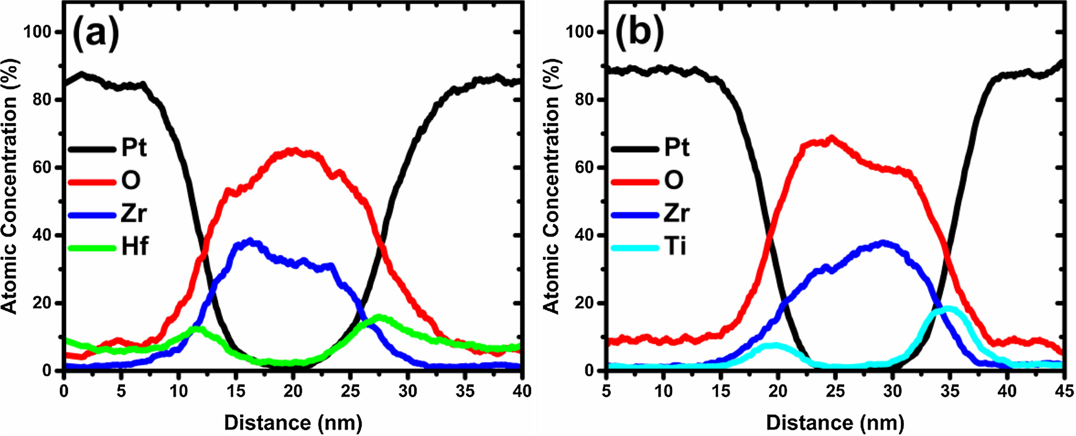

Fig. 3. TEM-EDS line profiles across the a) HZH and b) TZT samples after 600 °C N2 annealing for 30 s. Hf or Ti element can be observed between the ZrO2 thin films and the Pt electrodes, indicating the presence of the HfO2 and TiO2 interfacial layers in the HZH and TZT samples, respectively.

4040

S.-H. Yi, et al. *Journal of the European Ceram ic Society 39 (2019) 4038–4045*

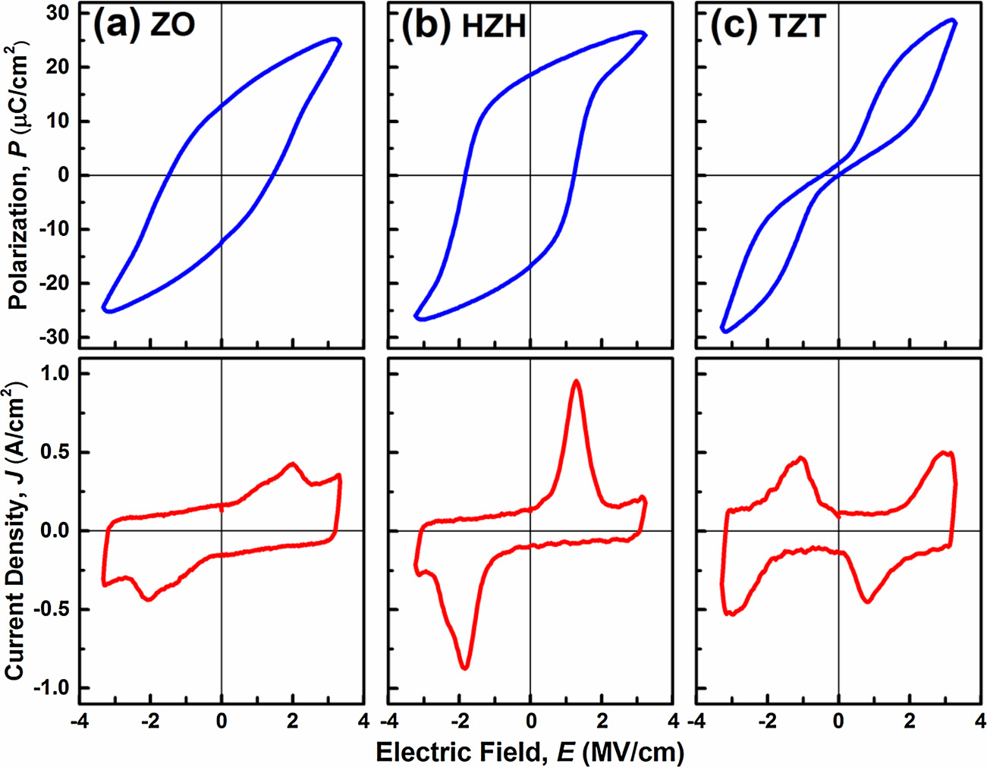

Fig. 4. P-E and J-E curves of the a) ZO, b) HZH, and c) TZT

samples after 600 °C N2 annealing for 30 s. Compared to the ZO sample, the HfO2 interfacial layers leads to significant enhancement of the Pr and switching current, while the TiO2 interfacial layers result in the conversion of the ZrO2 from the original FE state into the AFE state.

amount of the o-phase and the formation of higher o(111)/t(011) tex- applied, the t-phase may transform to the o-phase, giving rise to the

ture may account for the enhanced FE properties of the HZH compared to that of the ZO sample. Notice that the TZT sample only shows peaks around 35° and 74°, which originates from the first and second order t (110)/o(002) reflections. Thus the TZT thin film is highly textured, as manifested by the presence of only t(hh0)/o(00l) reflections in the 2 θ / ω XRD pattern.

In order to distinguish between the t(110) and o(002) peaks of the TZT sample, an in-plane XRD measurement was carried out. Because of the strong texture of the TZT thin film in the out-of-plane direction, most of the peaks in the in-plane XRD pattern originate from the planes perpendicular to the t(110) or o(002) plane, including the t(002)/o (020), t(110)/o(200), t(112)/o(220), t(004), t(220)/o(400) reflections as observed in Fig. 6a. It should be noted that the diffraction peak at 2θ χ=72.9° can only be ascribed to the (004) plane of the t-phase, as shown in Fig. 6b, which shows the in-plane XRD pattern performed at a slow scan rate from 2θ χ=70° to 77°. This confirms the presence of the t-phase with (110)-texture in the TZT thin film. As an electric field is

AFE characteristics of the TZT sample as shown in Fig. 4c [19,23,33].

The FE and AFE behaviors of the ZO, HZH, and TZT samples were also characterized by the C–V measurement, from which the dielectric constants were extracted. As shown in Fig. 7a, b, double peaks are observed in both the ZO and HZH samples, corresponding to the po-larization switching in the ferroelectrics. The TZT sample exhibits two pairs of peaks of the dielectric constant as seen in Fig. 7c, which is in good agreement with the AFE characteristics. The dielectric constants of the ZO, HZH, and TZT samples at the applied voltage of 0 V are approximately 32, 25, and 45, respectively. The dielectric constant decreased with the introduction of the HfO2 interfacial layers, but in-creased with the insertion of the TiO2 interfacial layers. The decrease of the dielectric constant in the HZH sample is attributed to the presence of the m-phase, which has a lower dielectric constant (∼20) than the o-phase (∼30–40) [19,34]. On the other hand, the increase of the di-electric constant in the TZT thin film can be understood from the for-mation of the highly-oriented t-phase with a higher dielectric constant

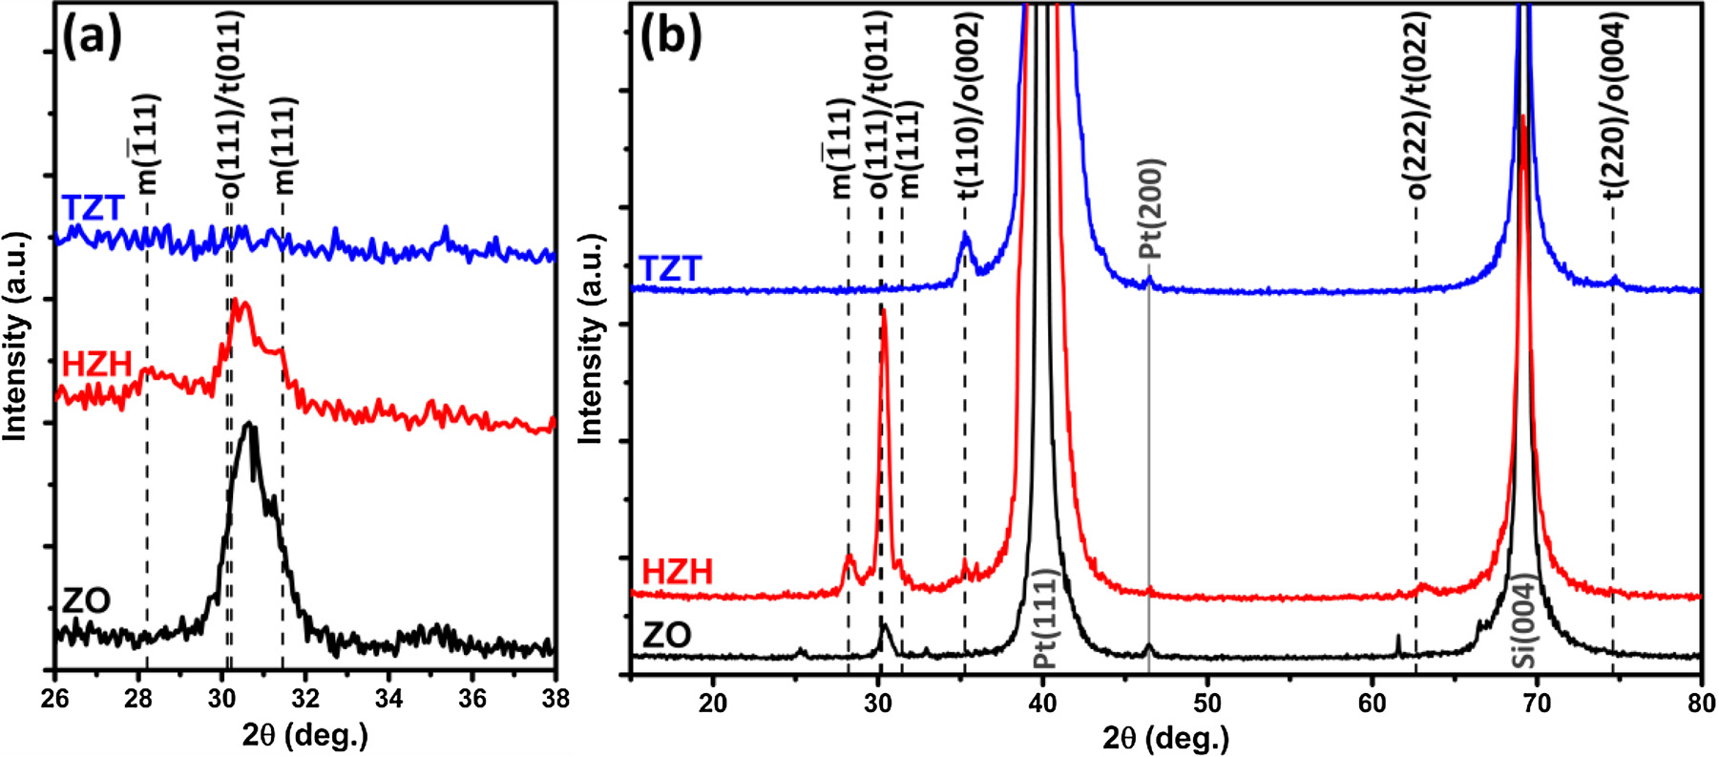

Fig. 5. a) GIXRD patterns of the ZO, HZH, and TZT samples after 600 °C N2 annealing for 30 s. The weak o(111)/t(011) reflection of the HZH and the absence of diffraction peak of the TZT imply the presence of a texture in the films. b) Out-of-plane XRD patterns of the ZO, HZH, and TZT samples. The HZH and TZT thin films exhibit the o-phase with (111)-texture and the t-phase with (110)-texture, respectively.

4041

S.-H. Yi, et al. *Journal of the European Ceram ic Society 39 (2019) 4038–4045*

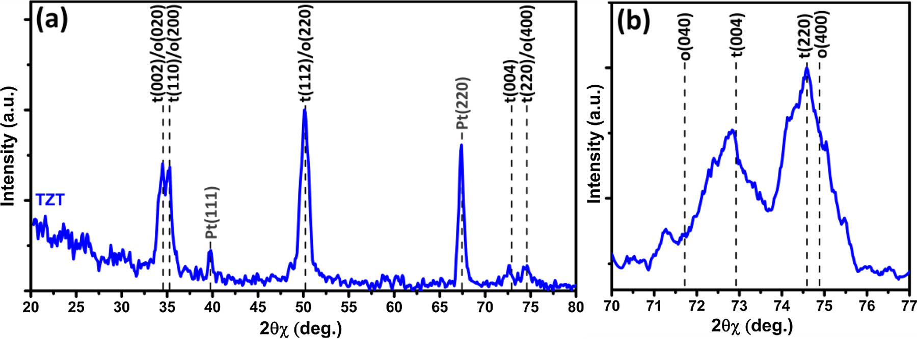

Fig. 6. In-plane XRD patterns of the TZT sample (after 600 °C N2 annealing for 30 s) with a) the 2θχ ranging from 10° to 90° and b) the 2θχ ranging from 70° to 77°

with a slow scan rate. All of the peaks in a) correspond to the planes perpendicular to the t(110) plane. The peak at 72.9° in b) is ascribed to the (004) reflection of the

t-phase. Thus, the TZT sample is confirmed to be the t-phase with (110)-texture.

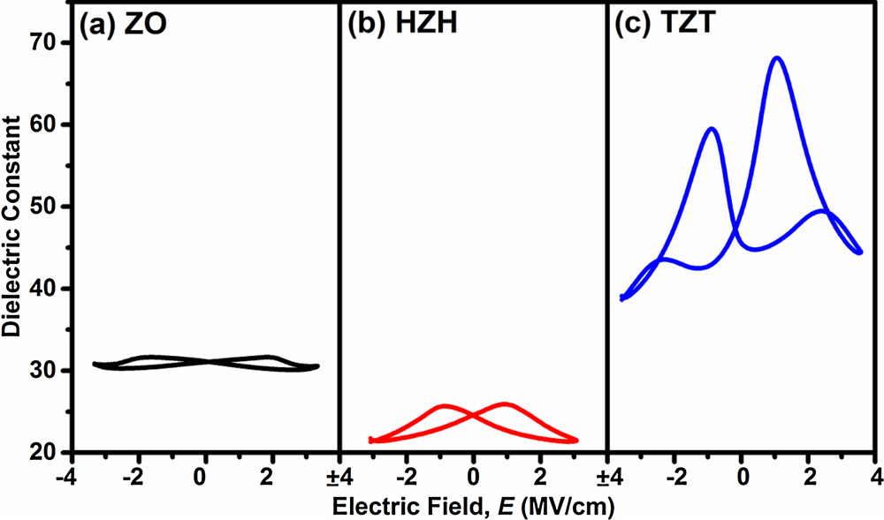

Fig. 7. The dielectric constants of the a) ZO, b) HZH, and c) TZT sample (after 600 °C N2 annealing for 30 s), which were extracted from the small-signal C–V measurement with an ac voltage of 30 mV at 100 kHz. The decrease/increase of the dielectric constants of HZH/TZT is ascribed to the presence of the m/t-phases, respectively, as revealed from the XRD patterns.

as large as 46 [19,34]. The decrease/increase of the dielectric constants agrees well with the presence of the m/t crystalline phases as revealed by the XRD patterns in Figs. 5 and 6.

The impact of the thickness of the HfO2 and TiO2 interfacial layers on the FE/AFE properties of ZrO2 is shown in Figs. 8 and 9. Fig. 8 shows that the ferroelectricity of the HZH samples is severely degraded as the thickness of the HfO2 interfacial layers increase from 0.6 nm to 2.3 nm. This is attributed to the presence of more m-phase in the HZH with the increased thickness of the HfO2 interfacial layers, as shown in the XRD patterns provided in Fig. S1a in Supplementary materials. It has been reported that HfO2 thin films tend to crystalize into the m-phase as the thickness increases [33,35], as supported by the presence of the m-phase in the XRD pattern of a 3-nm HfO2 thin film in Fig. S2a in Sup-plementary materials. Thus, the increase in the thickness of the HfO2 interfacial layers might provide more nucleation sites for the crystal-lization of the m-phase in the ZrO2 layer, which deteriorates the FE characteristics. In addition, a series connection of the FE ZrO2 layer with the paraelectric HfO2 layers also results in a degradation of the FE properties of the HZH sample [36,37]. On the other hand, Fig. 9 reveals that the thickness of the TiO2 interfacial layers (from 1 nm to 2.5 nm) has little impact on the AFE characteristics of the TZT samples. The result is supported by the XRD patterns provided in Fig. S1b in Sup-plementary materials, which demonstrates that the textured t-phase in the TZT samples has little change with the increase of the TiO2 thick-ness. In addition, it has been reported that the energy barrier between the conduction band of TiO2 and the Fermi level of Pt is small of only

∼0.3 eV [38]. Hence, the electrons in Pt can transport into the TiO2 layers due to the small energy barrier. Besides, the oxygen vacancies and defect states can facilitate the carrier transport in TiO2 [39]. Therefore, the TiO2 layer may behave much like a resistor instead of a capacitor. Accordingly, the TiO2 layers would not take much voltage drop as connected in series with the ZrO2 layer. As a result, the anti-ferroelectricity in the TZT samples is not as sensitive as the ferroelec-tricity in the HZH samples to the variation of the thickness of interfacial layers.

Impurity doping or alloying has been the prevalent method for tailoring the FE/AFE characteristics in dielectrics [18,26–28]. Because all the samples had been treated with a PMA process at 600 °C, there is a concern that the modulation of the ZrO2 FE/AFE properties may arise from the doping of Hf or Ti into ZrO2 instead of the effect of interfacial layers. To distinguish the effect of interfacial layers from that of the impurity doping/alloying, the FE/AFE characteristics of the as-de-posited ZO, HZH, and TZT samples (without the PMA treatment) were also measured. All the processing temperatures of the as-deposited samples did not exceed 300 °C, which is supposed to suppress the effect of impurity doping/alloying. As demonstrated in Fig. 10, the as-de-posited ZO, HZH, and TZT samples also exhibited FE/AFE behaviors similar to those shown in Fig. 4. The result reveals that the impurity doping/alloying from the interfacial layers into ZrO2 might not be the main contribution to the FE/AFE properties of the ZrO2 layer. Fur-thermore, it is demonstrated that the interface engineering by the HfO2/TiO2 interfacial layers is capable of tailoring the FE/AFE char-acteristics of ZrO2 thin films with significant enhancement or trans-formation without the need of high-temperature treatments, which is highly beneficial to the process integration for further device scaling in memory devices and negative capacitance transistors.

In order to explain the effect of the interfacial layers, the stabili-zation of the t- and o-phase in ZrO2 is discussed as follows. From the thermodynamic point of view, the effects of surface energy and strain play an important role for the stabilization of metastable crystalline phases [22,33]. For ZrO2, the metastable t-phase tends to be stabilized in nanoscale thin films due to the surface energy effect [33]. The o-phase is also a metastable phase in ZrO2, and its free energy is slightly higher than that of the t-phase as indicated by the first principle cal-culation [22,33]. Studies have indicated that the stabilization of the ZrO2 o-phase in nanoscale thin films cannot be achieved only by the surface energy effect [33,35]. Although it has been reported that the strain engineering is able to stabilize the o-phase in ZrO2 [23,40], the experimentally observed ferroelectricity is insignificant [40]. However, pronounced ferroelectric properties originating from the o-phase have been observed in nanoscale ZrO2 thin films [31,32,41]. As a result, mechanisms other than the surface energy and strain effects should be

4042

S.-H. Yi, et al. *Journal of the European Ceram ic Society 39 (2019) 4038–4045*

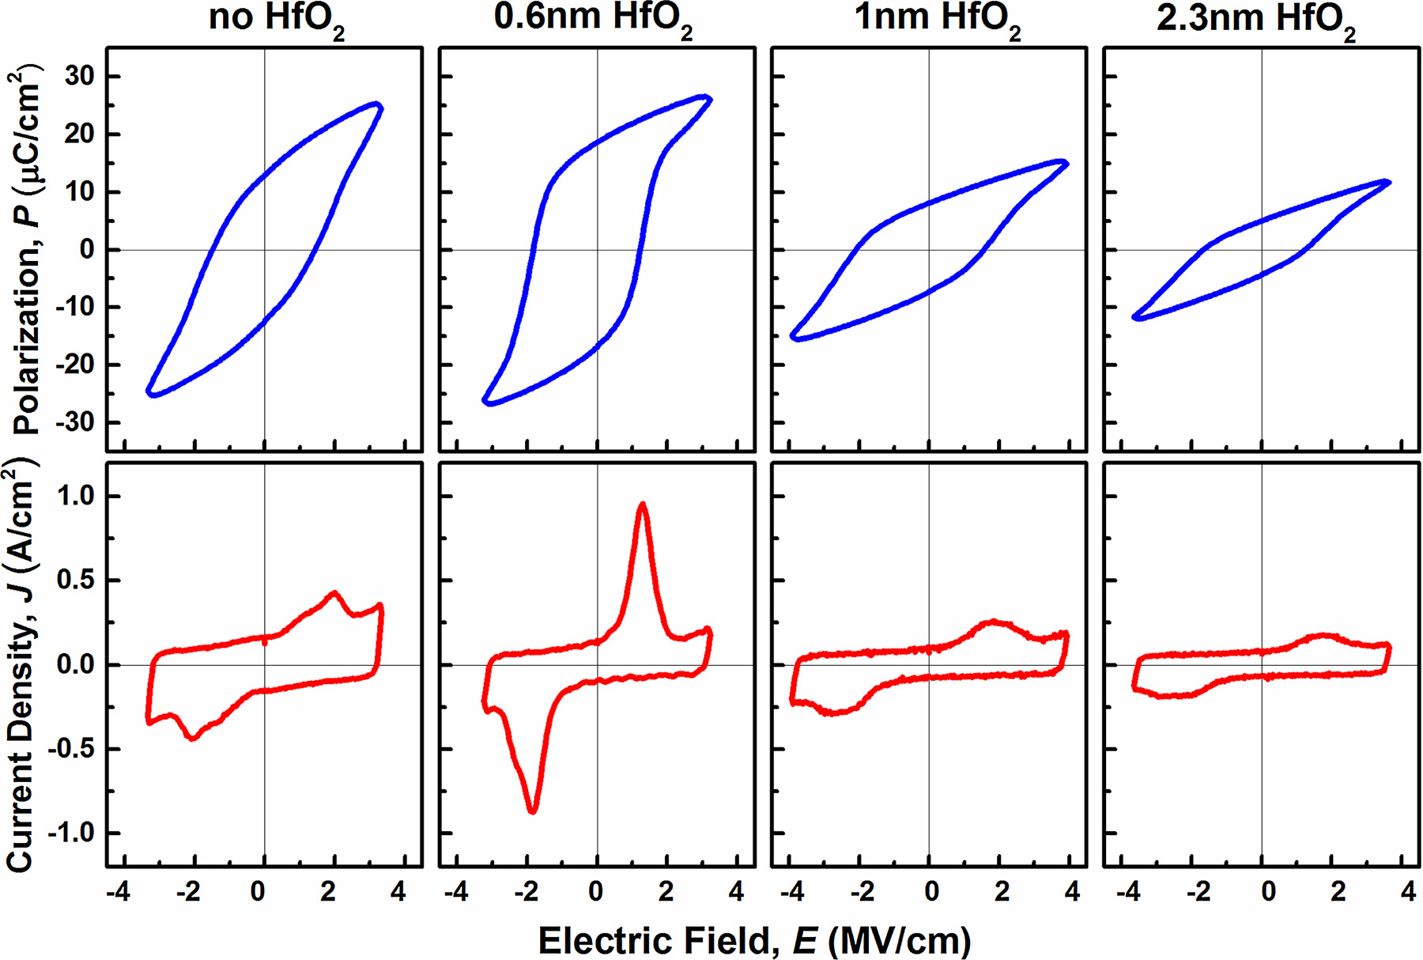

Fig. 8. Evolution of the P-E and J-E curves of the HZH sample (after 600 °C N2 annealing for 30 s) with an increase in the thickness of the HfO2 interfacial layers from 0 to 2.3 nm. The FE properties of the HZH are severely degraded when the HfO2 interfacial layers exceed 0.6 nm, owing to the increased amount of m-phase in the HfO2 and ZrO2.

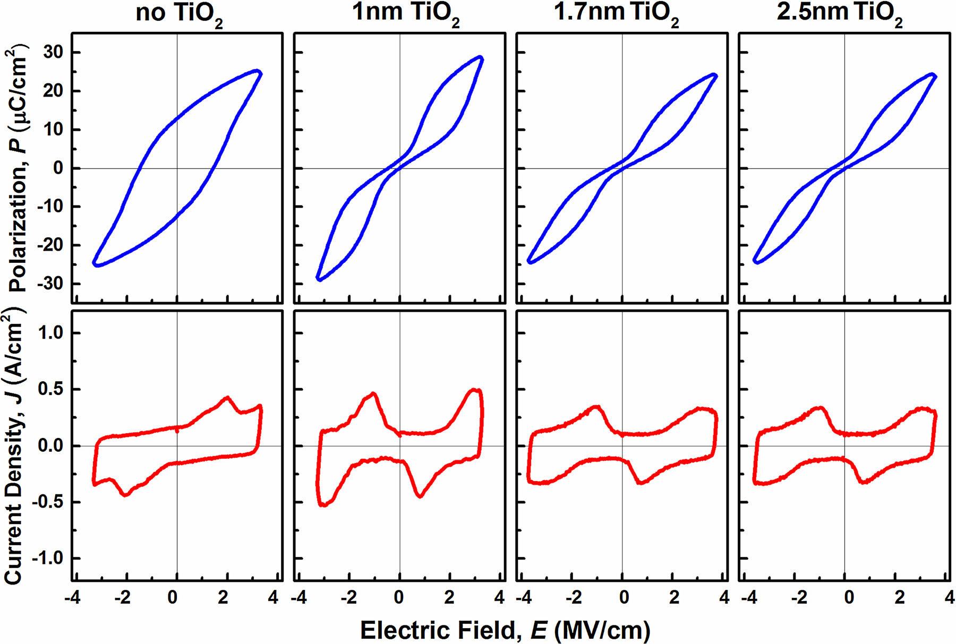

Fig. 9. Evolution of the P-E and J-E curves of the TZT sample (after 600 °C N2 annealing for 30 s) with an increase in the thickness of the TiO2 interfacial layers from 0 to 2.5 nm. The AFE properties of the TZT exhibit little degradation when the TiO2 interfacial layers exceed 1 nm.

4043

S.-H. Yi, et al. *Journal of the European Ceram ic Society 39 (2019) 4038–4045*

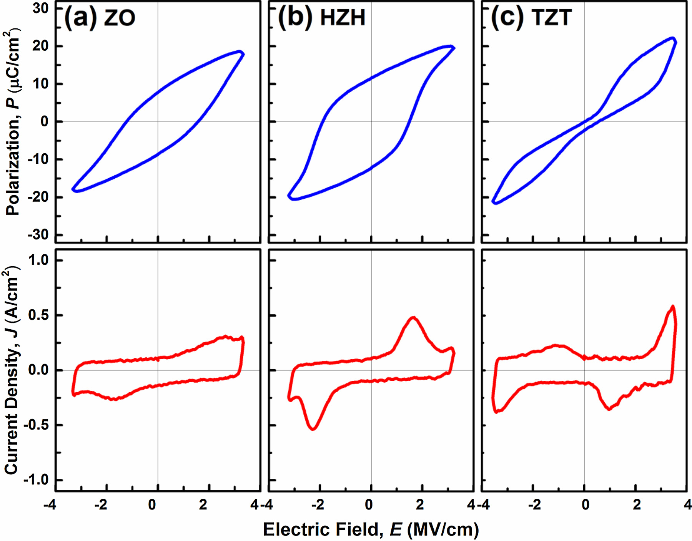

Fig. 10. P-E and J-E curves of the as-deposited a) ZO, b) HZH, and c) TZT samples. The characteristics of all the as-deposited samples are similar to those of the PMA-

treated samples, indicating the enhancement/transformation of the ZrO2 FE/AFE properties by the interfacial layers can be achieved without a PMA treatment.

introduced to explain the presence of the o-phase in nanoscale ZrO2 thin films. Park et al. suggested the complicated process of in-situ crystallization in plasma-enhanced ALD may be a possible reason [35]. Shibayama et al. proposed that the non-equilibrium deposition process favors the formation of the metastable o-phase from the kinetic point of view [41]. The in-situ crystallization and non-equilibrium deposition process fit the experimental conditions and results in this study. Therefore, these points of view should be taken into account to un-derstand the presence of the ferroelectric o-phase in ZrO2.

The impact of the interfacial layers on ferroelectricity/anti-ferroelectricity is proposed as follows. In ALD, the condition of sub-strate surface is critical to the growth mode of the overlying thin film during the initial deposition stage, which brings a significant impact on the formed crystalline phase [42]. Because of insufficient amount of reactive sites on the inert Pt surface for the chemisorption of ALD precursors, the growth of ZrO2 in the ZO sample supposedly tends to proceed in a non-equilibrium kinetic process in the first few ALD cycles, resulting in the island-like nucleation and in-situ crystallization to the o-phase [35,41,43]. These o-phase nuclei continue to develop in the subsequent ALD process, which leads to the formation of the o-phase in

in the XRD pattern, Fig. S2a) suppresses the formation of the o-phase

(Fig. S1a) and thus degrades the FE features of the overlying ZrO2 layer (Fig. 8). This outcome also supports the role of the HfO2 interfacial layer as the seeding layer for the ZrO2 growth.

For the TZT sample, the XRD pattern shown in Fig. S2b indicates the

amorphous structure in the 4-nm TiO2 layer after 600 °C N2 annealing for 30 s. Thus, the structure of ∼1 nm TiO2 interfacial layers is expected to be amorphous. The TiO2 interfacial layer would provide sufficient hydroxyl groups at the surface for the chemisorption of TDMAZ pre-

cursors for the deposition of ZrO2, which may prefer the near-equili-brium growth of initial ZrO2 nuclei. Thus, the thermodynamically fa-vorable t-phase would dominate over the o-phase during the film

growth. This accounts for the formation of t-phase in the TZT sample.

Moreover, the TiO2 interfacial layer remains amorphous as the thick-ness increases (Fig. S2b), which does not affect the crystalline t-phase of

the overlying ZrO2 layer. This explains the similar XRD patterns (Fig. S1b) and AFE characteristics (Fig. 9) of the TZT samples with different

thicknesses of the TiO2 interfacial layers.

the ZO sample. On the other hand, the thermodynamic study has pre- 4. Conclusion

dicted that the o-phase can be stabilized in HfO2 by the surface energy effect if the grain size is around 1 nm [35], which suggests that the HfO2 interfacial layers with a thickness ∼0.6 nm in the HZH sample may partially crystallize into the o-phase. The o-phase HfO2 then serves as nucleation sites for the growth of the overlying ZrO2, which facilitates the emergence of the o-phase (Fig. 5b) and enhances the FE properties (Fig. 4b) of the HZH sample. Furthermore, as the thickness of the HfO2 interfacial layers increases, the presence of the HfO2 m-phase (as shown

In this study, sub-nanometer TiO2 and HfO2 interfacial layers are demonstrated to have strong impact on the FE and AFE properties of

ZrO2 thin films. The HfO2 interfacial layers boost the formation of the orthorhombic phase in ZrO2 film with (111) texture, leading to sig-nificant enhancement of the ferroelectricity. The TiO2 interfacial layers contribute to the formation of the (110)-textured tetragonal ZrO2, giving rise to the pronounced antiferroelectricity ascribed to the field-

induced phase transition from the t- to the o-phase. Furthermore, the

4044

S.-H. Yi, et al. *Journal of the European Ceram ic Society 39 (2019) 4038–4045*

interface engineering by the HfO2/TiO2 interfacial layers could be achieved without high-temperature annealing, which is particularly favorable to CMOS process integration. The results show that interface engineering is a critical and effective approach to tailor the FE/AFE characteristics of materials.

Acknowledgments

The authors acknowledge the partially financial support in part by Taiwan Semiconductor Manufacturing Company (TSMC) and the Ministry of Science and Technology, Taiwan (MOST 108-2218-E-002-028).

Appendix A. Supplementary data

Supplementary material related to this article can be found, in the online version, at doi:[https://doi.org/10.1016/j.jeurceramsoc.2019.05. 065](https://doi.org/10.1016/j.jeurceramsoc.2019.05.065).

References

[1] [H. Kohlstedt, Y. Mustafa, A. Gerber, A. Petraru, M. Fitsilis, R. Meyer, U. Böttger, R. Waser, Current status and challenges of ferroelectric memory devices, Microelectron. Eng. 80 (2005) 296–304.](http://refhub.elsevier.com/S0955-2219(19)30398-X/sbref0005)

[2] [N. Setter, D. Damjanovic, L. Eng, G. Fox, S. Gevorgian, S. Hong, A. Kingon, H. Kohlstedt, N.Y. Park, G.B. Stephenson, I. Stolitchnov, A.K. Taganstev, D.V. Taylor, T. Yamada, S. Streif](http://refhub.elsevier.com/S0955-2219(19)30398-X/sbref0010)f[er, Ferroelectric thin f](http://refhub.elsevier.com/S0955-2219(19)30398-X/sbref0010)i[lms: review of materials, properties, and applications, J. Appl. Phys. 100 (5) (2006) 051606.](http://refhub.elsevier.com/S0955-2219(19)30398-X/sbref0010)

[3] [V. Garcia, M. Bibes, Ferroelectric tunnel junctions for information storage and](http://refhub.elsevier.com/S0955-2219(19)30398-X/sbref0015)  [processing, Nat. Commun. 5 (2014) 4289.](http://refhub.elsevier.com/S0955-2219(19)30398-X/sbref0015)

[4] [C. Kittel, Theory of antiferroelectric crystals, Phys. Rev. 82 (5) (1951) 729–732.](http://refhub.elsevier.com/S0955-2219(19)30398-X/sbref0020) [5] [K.M. Rabe, Antiferroelectricity in oxides: a reexamination, in: T. V.V, Satishchandra](http://refhub.elsevier.com/S0955-2219(19)30398-X/sbref0025)  [B. Ogale, Mark G. Blamire (Eds.), Functional Metal Oxides: New Science and Novel](http://refhub.elsevier.com/S0955-2219(19)30398-X/sbref0025)  [Applications, Wiley-VCH, Weinheim, Germany, 2013, pp. 221–244.](http://refhub.elsevier.com/S0955-2219(19)30398-X/sbref0025)

[6] [B. Jaf](http://refhub.elsevier.com/S0955-2219(19)30398-X/sbref0030)f[e, Antiferroelectric ceramics with f](http://refhub.elsevier.com/S0955-2219(19)30398-X/sbref0030)i[eld-enforced transitions: a new nonlinear](http://refhub.elsevier.com/S0955-2219(19)30398-X/sbref0030)  [circuit element, Proc. IRE 49 (8) (1961) 1264–1267.](http://refhub.elsevier.com/S0955-2219(19)30398-X/sbref0030)

[7] [M.H. Park, H.J. Kim, Y.J. Kim, T. Moon, K.D. Kim, C.S. Hwang, Toward a multi-functional monolithic device based on pyroelectricity and the electrocaloric ef](http://refhub.elsevier.com/S0955-2219(19)30398-X/sbref0035)f[ect of thin antiferroelectric HfxZr1−xO2 f](http://refhub.elsevier.com/S0955-2219(19)30398-X/sbref0035)i[lms, Nano Energy 12 (2015) 131–140.](http://refhub.elsevier.com/S0955-2219(19)30398-X/sbref0035)

[8] [A.S. Mischenko, Q. Zhang, J.F. Scott, R.W. Whatmore, N.D. Mathur, Giant elec-trocaloric ef](http://refhub.elsevier.com/S0955-2219(19)30398-X/sbref0040)f[ect in thin-f](http://refhub.elsevier.com/S0955-2219(19)30398-X/sbref0040)i[lm PbZr0.95Ti0.05O3, Science 311 (5765) (2006) 1270–1271.](http://refhub.elsevier.com/S0955-2219(19)30398-X/sbref0040)

[9] [W. Geng, Y. Liu, X. Meng, L. Bellaiche, J.F. Scott, B. Dkhil, A. Jiang, Giant negative electrocaloric ef](http://refhub.elsevier.com/S0955-2219(19)30398-X/sbref0045)f[ect in antiferroelectric La-doped Pb(ZrTi)O3 thin f](http://refhub.elsevier.com/S0955-2219(19)30398-X/sbref0045)i[lms near room temperature, Adv. Mater. 27 (20) (2015) 3165–3169.](http://refhub.elsevier.com/S0955-2219(19)30398-X/sbref0045)

[10] [R.W. Whatmore, Pyroelectric arrays: ceramics and thin f](http://refhub.elsevier.com/S0955-2219(19)30398-X/sbref0050)i[lms, J. Electroceram. 13](http://refhub.elsevier.com/S0955-2219(19)30398-X/sbref0050)  [(1) (2004) 139–147.](http://refhub.elsevier.com/S0955-2219(19)30398-X/sbref0050)

[11] [X.-D. Weng, Q.-Q. Sun, A.-Q. Jiang, D.-W. Zhang, Characterization of Au/Pb (Zr0.96Ti0.04)O3/Al2O3/Si antiferroelectric f](http://refhub.elsevier.com/S0955-2219(19)30398-X/sbref0055)i[eld-ef](http://refhub.elsevier.com/S0955-2219(19)30398-X/sbref0055)f[ect transistors for memory ap-plication, J. Electroceram. 25 (2) (2010) 174–178.](http://refhub.elsevier.com/S0955-2219(19)30398-X/sbref0055)

[12] [M. Pe](http://refhub.elsevier.com/S0955-2219(19)30398-X/sbref0060)[š](http://refhub.elsevier.com/S0955-2219(19)30398-X/sbref0055)[i](http://refhub.elsevier.com/S0955-2219(19)30398-X/sbref0060)[ć](http://refhub.elsevier.com/S0955-2219(19)30398-X/sbref0055)[, M. Hof](http://refhub.elsevier.com/S0955-2219(19)30398-X/sbref0060)f[mann, C. Richter, T. Mikolajick, U. Schroeder, Nonvolatile random access memory and energy storage based on antiferroelectric like hysteresis in ZrO2, Adv. Funct. Mater. 26 (41) (2016) 7486–7494.](http://refhub.elsevier.com/S0955-2219(19)30398-X/sbref0060)

[13] [S. Salahuddin, S. Datta, Use of negative capacitance to provide voltage amplif](http://refhub.elsevier.com/S0955-2219(19)30398-X/sbref0065)i[ca-](http://refhub.elsevier.com/S0955-2219(19)30398-X/sbref0065) [tion for low power nanoscale devices, Nano Lett. 8 (2) (2008) 405–410.](http://refhub.elsevier.com/S0955-2219(19)30398-X/sbref0065)

[14] [K. Karda, A. Jain, C. Mouli, M.A. Alam, An anti-ferroelectric gated Landau transistor to achieve sub-60 mV/dec switching at low voltage and high speed, Appl. Phys. Lett. 106 (16) (2015) 163501.](http://refhub.elsevier.com/S0955-2219(19)30398-X/sbref0070)

[15] [S. Dasgupta, A. Rajashekhar, K. Majumdar, N. Agrawal, A. Razavieh, S. Trolier-Mckinstry, S. Datta, Sub-kT/q switching in strong inversion in PbZr0.52Ti0.48O3 gated negative capacitance FETs, IEEE J. Explor. Solid-State Computat. Devices Circuits 1 (2015) 43–48.](http://refhub.elsevier.com/S0955-2219(19)30398-X/sbref0075)

[16] [M.H. Lee, Y. Wei, K. Chu, J. Huang, C. Chen, C. Cheng, M. Chen, H. Lee, Y. Chen, L. Lee, M. Tsai, Steep slope and near non-hysteresis of FETs with antiferroelectric-like HfZrO for low-power electronics, IEEE Electron Device Lett. 36 (4) (2015) 294–296.](http://refhub.elsevier.com/S0955-2219(19)30398-X/sbref0080)

[17] [X.H. Hao, J.W. Zhai, L.B. Kong, Z.K. Xu, A comprehensive review on the progress of](http://refhub.elsevier.com/S0955-2219(19)30398-X/sbref0085)

[lead zirconate-based antiferroelectric materials, Prog. Mater. Sci. 63 (2014) 1–57.](http://refhub.elsevier.com/S0955-2219(19)30398-X/sbref0085) [18] [T. Böscke, J. Müller, D. Bräuhaus, U. Schröder, U. Böttger, Ferroelectricity in haf-nium oxide thin f](http://refhub.elsevier.com/S0955-2219(19)30398-X/sbref0090)i[lms, Appl. Phys. Lett. 99 (10) (2011) 102903.](http://refhub.elsevier.com/S0955-2219(19)30398-X/sbref0090)

[19] [J. Muller, T.S. Boscke, U. Schroder, S. Mueller, D. Brauhaus, U. Bottger, L. Frey, T. Mikolajick, Ferroelectricity in simple binary ZrO2 and HfO2, Nano Lett. 12 (8) (2012) 4318–4323.](http://refhub.elsevier.com/S0955-2219(19)30398-X/sbref0095)

[20] [K.D. Kim, M.H. Park, H.J. Kim, Y.J. Kim, T. Moon, Y.H. Lee, S.D. Hyun, T. Gwon, C.S. Hwang, Ferroelectricity in undoped-HfO2 thin f](http://refhub.elsevier.com/S0955-2219(19)30398-X/sbref0100)i[lms induced by deposition temperature control during atomic layer deposition, J. Mater. Chem. C 4 (28) (2016) 6864–6872.](http://refhub.elsevier.com/S0955-2219(19)30398-X/sbref0100)

[21] [X. Sang, E.D. Grimley, T. Schenk, U. Schroeder, J.M. LeBeau, On the structural origins of ferroelectricity in HfO2 thin f](http://refhub.elsevier.com/S0955-2219(19)30398-X/sbref0105)i[lms, Appl. Phys. Lett. 106 (16) (2015) 162905.](http://refhub.elsevier.com/S0955-2219(19)30398-X/sbref0105)

[22] [E.H. Kisi, C.J. Howard, R.J. Hill, Crystal structure of orthorhombic zirconia in](http://refhub.elsevier.com/S0955-2219(19)30398-X/sbref0110)  [partially stabilized zirconia, J. Am. Ceram. Soc. 72 (9) (1989) 1757–1760.](http://refhub.elsevier.com/S0955-2219(19)30398-X/sbref0110)

[23] [S.E. Reyes-Lillo, K.F. Garrity, K.M. Rabe, Antiferroelectricity in thin-f](http://refhub.elsevier.com/S0955-2219(19)30398-X/sbref0115)i[lm ZrO2 from](http://refhub.elsevier.com/S0955-2219(19)30398-X/sbref0115)  [f](http://refhub.elsevier.com/S0955-2219(19)30398-X/sbref0115)i[rst principles, Phys. Rev. B 90 (14) (2014) 140103.](http://refhub.elsevier.com/S0955-2219(19)30398-X/sbref0115)

[24] [R. Ruh, P.W.R. Corf](http://refhub.elsevier.com/S0955-2219(19)30398-X/sbref0120)i[eld, Crystal structure of monoclinic Hafnia and comparison](http://refhub.elsevier.com/S0955-2219(19)30398-X/sbref0120)  [with monoclinic zirconia, J. Am. Ceram. Soc. 53 (3) (1970) 126–129.](http://refhub.elsevier.com/S0955-2219(19)30398-X/sbref0120)

[25] [E.H. Kisi, C.J. Howard, Crystal structures of zirconia phases and their inter-relation,](http://refhub.elsevier.com/S0955-2219(19)30398-X/sbref0125)  [Key Eng. Mater. (1998) 1–36.](http://refhub.elsevier.com/S0955-2219(19)30398-X/sbref0125)

[26] [M.H. Park, Y.H. Lee, H.J. Kim, Y.J. Kim, T. Moon, K.D. Kim, J. Muller, A. Kersch, U. Schroeder, T. Mikolajick, C.S. Hwang, Ferroelectricity and antiferroelectricity of doped thin HfO2-based f](http://refhub.elsevier.com/S0955-2219(19)30398-X/sbref0130)i[lms, Adv. Mater. 27 (11) (2015) 1811–1831.](http://refhub.elsevier.com/S0955-2219(19)30398-X/sbref0130)

[27] [D. Lehninger, D. Rafaja, J. Wünsche, F. Schneider, J.V. Borany, J. Heitmann, Formation of orthorhombic (Zr,Ta)O2 in thin Zr-Ta-O f](http://refhub.elsevier.com/S0955-2219(19)30398-X/sbref0135)i[lms, Appl. Phys. Lett. 110 (26) (2017) 262903.](http://refhub.elsevier.com/S0955-2219(19)30398-X/sbref0135)

[28] [S. Starschich, U. Böttger, Doped ZrO2 for future lead free piezoelectric devices, J.](http://refhub.elsevier.com/S0955-2219(19)30398-X/sbref0140)  [Appl. Phys. 123 (4) (2018) 044101.](http://refhub.elsevier.com/S0955-2219(19)30398-X/sbref0140)

[29] [M. Hyuk Park, H. Joon Kim, Y. Jin Kim, T. Moon, C. Seong Hwang, The ef](http://refhub.elsevier.com/S0955-2219(19)30398-X/sbref0145)f[ects of crystallographic orientation and strain of thin Hf0.5Zr0.5O2 f](http://refhub.elsevier.com/S0955-2219(19)30398-X/sbref0145)i[lm on its ferroelec-tricity, Appl. Phys. Lett. 104 (7) (2014) 072901.](http://refhub.elsevier.com/S0955-2219(19)30398-X/sbref0145)

[30] [Z. Wang, A.A. Gaskell, M. Dopita, D. Kriegner, N. Tasneem, J. Mack, N. Mukherjee, Z. Karim, A.I. Khan, Antiferroelectricity in lanthanum doped zirconia without me-tallic capping layers and post-deposition/-metallization anneals, Appl. Phys. Lett. 112 (22) (2018) 222902.](http://refhub.elsevier.com/S0955-2219(19)30398-X/sbref0150)

[31] [B.-T. Lin, Y.-W. Lu, J. Shieh, M.-J. Chen, Induction of ferroelectricity in nanoscale ZrO2 thin f](http://refhub.elsevier.com/S0955-2219(19)30398-X/sbref0155)i[lms on Pt electrode without post-annealing, J. Eur. Ceram. Soc. 37 (3) (2017) 1135–1139.](http://refhub.elsevier.com/S0955-2219(19)30398-X/sbref0155)

[32] [S. Starschich, T. Schenk, U. Schroeder, U. Boettger, Ferroelectric and piezoelectric properties of Hf1-xZrxO2 and pure ZrO2 f](http://refhub.elsevier.com/S0955-2219(19)30398-X/sbref0160)i[lms, Appl. Phys. Lett. 110 (18) (2017) 182905.](http://refhub.elsevier.com/S0955-2219(19)30398-X/sbref0160)

[33] [R. Materlik, C. Kunneth, A. Kersch, The origin of ferroelectricity in Hf1-xZrxO2: a computational investigation and a surface energy model, J. Appl. Phys. 117 (13) (2015) 134109.](http://refhub.elsevier.com/S0955-2219(19)30398-X/sbref0165)

[34] [X.Y. Zhao, D. Vanderbilt, Phonons and lattice dielectric properties of zirconia, Phys.](http://refhub.elsevier.com/S0955-2219(19)30398-X/sbref0170)  [Rev. B 65 (7) (2002) 075105.](http://refhub.elsevier.com/S0955-2219(19)30398-X/sbref0170)

[35] [M.H. Park, Y.H. Lee, H.J. Kim, T. Schenk, W. Lee, K.D. Kim, F.P.G. Fengler, T. Mikolajick, U. Schroeder, C.S. Hwang, Surface and grain boundary energy as the key enabler of ferroelectricity in nanoscale hafnia-zirconia: a comparison of model and experiment, Nanoscale 9 (28) (2017) 9973–9986.](http://refhub.elsevier.com/S0955-2219(19)30398-X/sbref0175)

[36] [A.K. Tagantsev, G. Gerra, Interface-induced phenomena in polarization response of](http://refhub.elsevier.com/S0955-2219(19)30398-X/sbref0180)  [ferroelectric thin f](http://refhub.elsevier.com/S0955-2219(19)30398-X/sbref0180)i[lms, J. Appl. Phys. 100 (5) (2006) 051607.](http://refhub.elsevier.com/S0955-2219(19)30398-X/sbref0180)

[37] [C.T. Black, C. Farrell, T.J. Licata, Suppression of ferroelectric polarization by an](http://refhub.elsevier.com/S0955-2219(19)30398-X/sbref0185)  [adjustable depolarization f](http://refhub.elsevier.com/S0955-2219(19)30398-X/sbref0185)i[eld, Appl. Phys. Lett. 71 (14) (1997) 2041–2043.](http://refhub.elsevier.com/S0955-2219(19)30398-X/sbref0185)

[38] [J. Klett, J. Ziegler, A. Radetinac, B. Kaiser, R. Schäfer, W. Jaegermann, F. Urbain, J.-P. Becker, V. Smirnov, F. Finger, Band engineering for ef](http://refhub.elsevier.com/S0955-2219(19)30398-X/sbref0190)fi[cient catalyst-substrate coupling for photoelectrochemical water splitting, PCCP 18 (16) (2016)](http://refhub.elsevier.com/S0955-2219(19)30398-X/sbref0190)   
[10751–10757.](http://refhub.elsevier.com/S0955-2219(19)30398-X/sbref0190)

[39] [H.H. Pham, L.-W. Wang, Oxygen vacancy and hole conduction in amorphous TiO2,](http://refhub.elsevier.com/S0955-2219(19)30398-X/sbref0195)  [PCCP 17 (1) (2015) 541–550.](http://refhub.elsevier.com/S0955-2219(19)30398-X/sbref0195)

[40] [Z. Fan, J.Y. Deng, J.X. Wang, Z.Y. Liu, P. Yang, J.X. Xiao, X.B. Yan, Z.L. Dong, J. Wang, J.S. Chen, Ferroelectricity emerging in strained (111)-textured ZrO2 thin f](http://refhub.elsevier.com/S0955-2219(19)30398-X/sbref0200)i[lms, Appl. Phys. Lett. 108 (1) (2016) 012906.](http://refhub.elsevier.com/S0955-2219(19)30398-X/sbref0200)

[41] [S. Shibayama, T. Nishimura, S. Migita, A. Toriumi, Thermodynamic control of ferroelectric-phase formation in HfxZr1−xO2 and ZrO2, J. Appl. Phys. 124 (18) (2018) 184101.](http://refhub.elsevier.com/S0955-2219(19)30398-X/sbref0205)

[42] [V. Miikkulainen, M. Leskelä, M. Ritala, R.L. Puurunen, Crystallinity of inorganic f](http://refhub.elsevier.com/S0955-2219(19)30398-X/sbref0210)i[lms grown by atomic layer deposition: overview and general trends, J. Appl. Phys. 113 (2) (2013) 021301.](http://refhub.elsevier.com/S0955-2219(19)30398-X/sbref0210)

[43] [C.-H. Chang, Y.-K. Chiou, C.-W. Hsu, T.-B. Wu, Hydrous-plasma treatment of Pt electrodes for atomic layer deposition of ultrathin High-k oxide f](http://refhub.elsevier.com/S0955-2219(19)30398-X/sbref0215)i[lms, Electrochem. Solid-State Lett. 10 (3) (2007) G5–G7.](http://refhub.elsevier.com/S0955-2219(19)30398-X/sbref0215)

4045